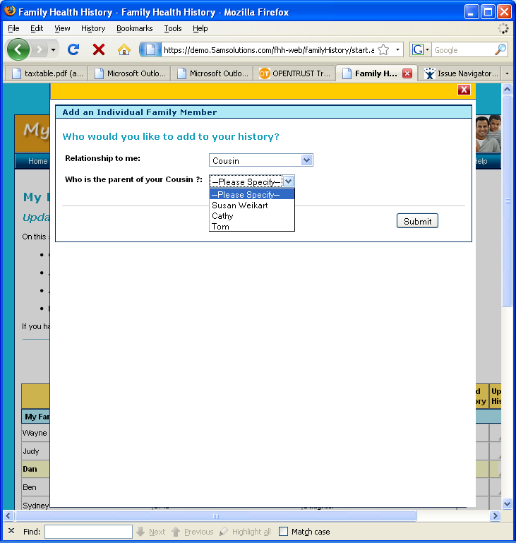
Add Individual Family Member Help
Add a family member by choosing the family role from the drop down list. To add that family member to your health history click submit. To add a nephew, niece or cousin, choose the parent of that family member in the next drop down list. You may not add a nephew, niece or cousin without adding their parent first. For example:
- Before adding a cousin, you must enter their parent first. Your cousin’s parent would be your aunt or uncle.
- Before adding a niece or nephew, you must add your brother or sister who is their parent first.

